**Project Plant Design Document**

Project plant is a game design project with the intention of being presentable by the time IGF comes around. The game will be developed for PC while keeping mobile platforms in mind

Project Plant’s basic gameplay will consist of managing two “areas” simultaneously. The player will manage tree’s branches above ground, and the roots below ground. Both areas will play differently but will affect resources available for the other area.

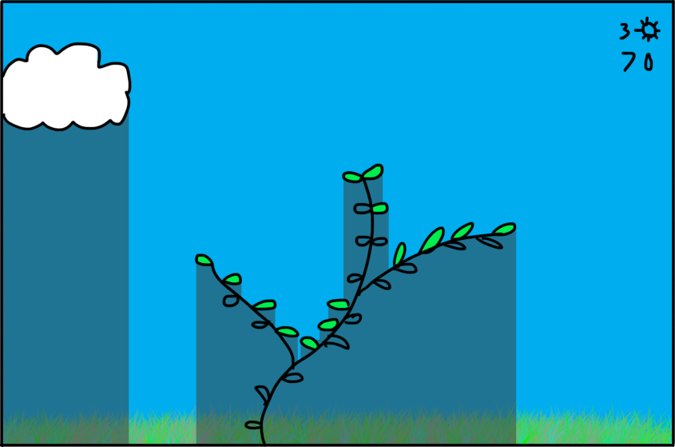

Above ground the player will grow his plant by clicking on the branch he wishes to invest his water points in. These branches will grow longer or split, and leaves will automatically sprout on them. Areas under branches will be cast in shadow and will not allow leaves to collect sun points.

Here the player receives constant sun points over time based on how many leaves are exposed to sunlight.

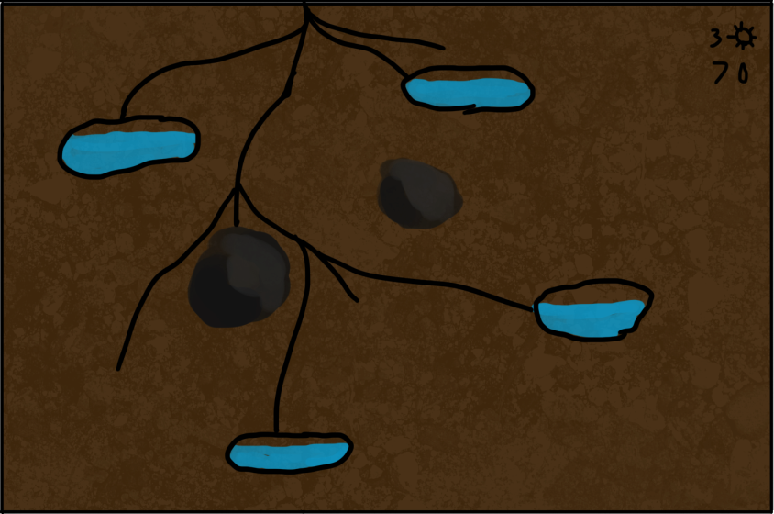

Sun points are then used by the player to “draw” the roots towards water (for water points to use above ground) and possibly other objects or targets.

**Hindrances and general Challenges**

These are possible elements of gameplay to make it more difficult/interesting.

-limited water supply (water runs out, we could make a visual cue for this)

-limited solar supply (clouds roll in, obscuring all leaves)

-there are other plants (branches casting shadows above ground and roots blocking your access underground) The plants can be defeated by covering them in shadow, thus freeing up the resources they held locked off. They *could* grow, but it would have to be scripted.

-limited starting resources

**Goals and Objectives**

The goals can be extremely varied so long as the core gameplay remains the same.

Here are some suggested goals we’ve explored today.

-Target height. Grow your plant tall enough to reach it.

-Target network. Grow your roots out enough

-Topside Target. Reach a target with your branches.

-Underground Target. Reach a target with your roots.

-Get a certain amount of leaves.

-Collect all resources.

-Kill off other plants.

-Time limit (clouds roll in at the end, or something similar)

-Collect a certain quantity of a resource

**Other Considerations**

At this point we can begin considering simple additional elements that could make it into the game, such as a simple ingame store that can sell different leaf patterns, different growth patterns, and other things.

-Ingame item store

-AI enemies (could be interesting to try and grow faster than an AI player)

-multiplayer, leaderboards, online functionalities

-New gameplay mechanics like insects, weather patterns, and earthquakes